 | 44 | 44 | 35 |  | _ | Sergio Colmenar Uribe | 1:19:52 (tr 1:19:49 )
 | 45 | 45 | 29 | i | _ | Ferran Rey Roncero | 1:19:53 (tr 1:19:49 )
 | 46 | 46 | 1383 | i | _ | Moi Rossell Perez | 1:19:53 (tr 1:19:49 )
 | 164 | 162 | 1357 | i | _ | Joan carles Reyes Bellerino | 1:26:02 (tr 1:25:43 )
 | 590 | 25 | 700 |  | _ | Sonia Nieto Molina | 1:38:32 (tr 1:37:06 )
 | 1763 | 1495 | 893 | 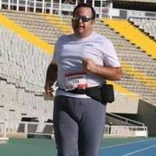 | _ | Candido Ferreiro Legide | 2:26:56 (tr 2:25:09 )
 | 1764 | 1496 | 877 | i | _ | Isidre Ferrer Cantal | 2:26:56 (tr 2:25:10 )

